Project Design Phase-II
Technology Stack (Architecture & Stack)

Date | 29.09.2026
Team ID | 6AP3D7136F290BE8A6B32917
Project Name | AI FAQ ASSISTANT API
Maximum Marks | 4 Marks

Technical Architecture
The AI FAQ Assistant API follows a modular RESTful backend architecture. The system uses Node.js and Express.js for application processing, MongoDB with Mongoose for data storage, JWT and bcrypt for security, and Google Gemini AI for intelligent question answering and FAQ generation.

Technical Architecture Diagram
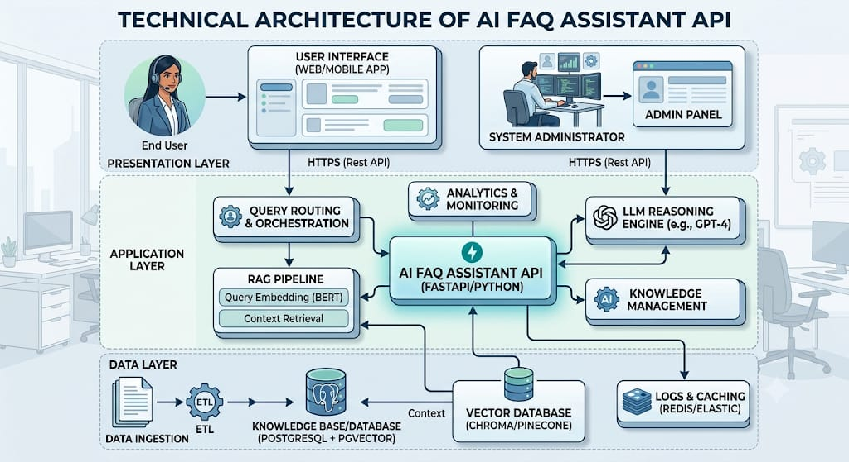

Table-1: Components & Technologies
S.No | Component | Description | Technology
1 | API Client / User Interface | Used to send API requests and receive JSON responses. | Postman / REST Client
2 | Application Logic-1 | Handles HTTP requests, API routes and application processing. | Node.js, Express.js
3 | Application Logic-2 | Handles user registration, login and profile operations. | JavaScript, JWT, bcrypt
4 | Application Logic-3 | Handles FAQ management, search and AI operations. | JavaScript, Express.js
5 | Database | Stores user and FAQ information as MongoDB documents. | MongoDB, Mongoose
6 | Cloud Database | Cloud database is not specifically defined in the provided project. | Not Applicable
7 | File Storage | No separate file-storage component is used by the application. | Not Applicable
8 | External API-1 | Provides AI-powered question answering and FAQ generation. | Google Gemini AI API
9 | External API-2 | No second external API is specified in the project. | Not Applicable
10 | Machine Learning / AI Model | Generates answers and FAQ question-and-answer pairs from user input. | Google Gemini AI
11 | Infrastructure (Server / Cloud) | Backend runs as a Node.js server and can be accessed through an API client. | Node.js Server / Local Environment

Table-2: Application Characteristics
S.No | Characteristics | Description | Technology
1 | Open-Source Frameworks | The application uses open-source backend frameworks and libraries for API development, database management and middleware processing. | Node.js, Express.js, Mongoose
2 | Security Implementations | Passwords are hashed using bcrypt and protected API endpoints use JWT authentication. Environment variables are used for sensitive configuration values. | bcrypt, JWT, dotenv
3 | Scalable Architecture | The modular structure separates routes, controllers, services, models, middleware and configuration, making the application easier to maintain and extend. | Node.js, Express.js, Mongoose
4 | Availability | The API is available when the Node.js server, MongoDB database and required Gemini AI service are accessible. | Node.js, MongoDB, Google Gemini AI
5 | Performance | RESTful API endpoints, MongoDB database operations and modular processing support efficient request handling. | Express.js, MongoDB, Mongoose

References
Use the same references given in your Naan Mudhalvan template:
- C4 Model
- IBM Cloud Architecture
- AWS Architecture
- Technical Architecture Diagram guidelines

